卡通人物

**CUChat: UML Specification and UI**

**Design Document**

Department of Computer Science and Engineering

 The Chinese University of Hong Kong

March 30, 2024

**Group E4**

An Keyu, 1155174008

Wang Zixin, 1155173944

Huang Yanwen, 1155157280

Yuan Lin, 1155141399

Yao Shihurong, 1155157155

**Table of Contents**

1. UML Design
   1. Component: Account and Message
      1. UMLs
      2. Functionality
      3. Procedures and Function
   2. Component: Home, Post and Comment
      1. UMLs
      2. Functionality
      3. Procedures and Function
2. UI Design
   1. User Interface – Authentication
      1. Default Page
      2. Log-in Page
      3. Sign-up Page
   2. User Interface - Admin Homepage
      1. Admin Homepage
      2. User Management Page
      3. Post Management Page
   3. User Interface - User Homepage
      1. Home Page
      2. Explore/Browse Page
      3. Notification Page
      4. Chat Page
      5. Profile Page
      6. Followers/Following Page
      7. Post Detail Page
3. Image Reference
4. UML DESIGN
   1. Component: Account and Message

1.1.1 UMLs

1.1.1.1 Structural Diagram – Component Diagram

图形用户界面

1.1.1.2 Use-case Diagram

1.1.1.3 Class Diagram

图形用户界面

1.1.1.4 Sequence Diagram

1.1.2 Functionality

This component provides services related to accounts and inter-user communication. The parent class Account consists of attributes UserID, Username, and Password. In the authentication process, UserID and Password are required for logging in CUChat, and logged-in accounts can be logged out. Two heir classes, Admin and User, inherit from the Account class. The Admin class includes functions for CRUD operations on User, Post, and Comment. The User class is designed for normal users. Apart from attributes inherited from Account, it also includes LikePostID, DislikedPostID, Followers, and Followings that record their interaction with other users and posts. New normal users can use the Register function to sign up for a new account. After logging in, the user can fetch users’ basic information, search for other users, follow/unfollow other users, and edit his own profile. The Message class includes attributes Time, ToUserID, FromUserID, and Content. Users can use the Message module to fetch their messages with other users and send new messages to other users.

1.1.3 Procedures and Functions

Account Class

|  |  |
| --- | --- |
| **Function** | **Description** |
| Login | The user need to provide UserID and Password to log in the account. Upon successful authentication, the user will be redirect to his Homepage; otherwise, the system will return warning and stay in the log-in page. |
| Logout | Logged-in users can destroy their client sessions. Upon successful log-out request, the user will be redirect to the log-in page. |

User Class

|  |  |
| --- | --- |
| **Function** | **Description** |
| FetchUser | The user can view other users’ profile through the FetchUser function by providing the selected user’s UserID. |
| EditUser | The user can edit his own profile through the EditUser function by providing his own UserID and the updated profile information. |
| FollowUser | The user can follow another users or unfollow his following users through this function by providing other users’ userID. |
| RemoveFollower | The user can remove his own followers by providing that user’s userID. |
| DisplayFollower | The user can view his follower or following list that was fetched from the account database by providing his own userID. |
| DisplayPost | The user can view his liked or self-released posts that are fetched from the post database by providing his own userID. |
| SearchForUser | The user can search for other users from the account database by providing other users’ userID. |
| Register | New users can provide a valid username, and a valid password to sign up for a new account. Upon successful registration, the user will be redirect to the default page. Otherwise, a warning message will be displayed and the system will stay in the same page. |

Admin Class

|  |  |
| --- | --- |
| **Function** | **Description** |
| CreateUser | The admin can create a new user through the management interface by providing a valid username, a valid and unique userID, and a valid password. |
| ListUserInformation | The admin can fetch and browse all users’ information, including their profile information and related post/comment/comment information. |
| EditUserInformation | The admin can edit any user’s profile by providing the user’s UserID and the updated information. |
| DeleteUser | The admin can delete any user by providing the user’s UserID. |
| CommentDelete | The admin can delete any comment by providing the comment’s commentID. |
| PostDelete | The admin can delete any post and the comments below by providing the postID. |

Message Class

|  |  |
| --- | --- |
| **Function** | **Description** |
| SendMessage | The user can send message to other users through the chat interface by providing the message content. |
| FetchMessage | The user can view chat history with another user in the chat interface. |

1.2 Component: Home, Post and Comment

1.2.1 UMLs

1.2.1.1 Structural Diagram – Component Diagram

1.2.1.2 Use-case Diagram

1.2.1.3 Class Diagram

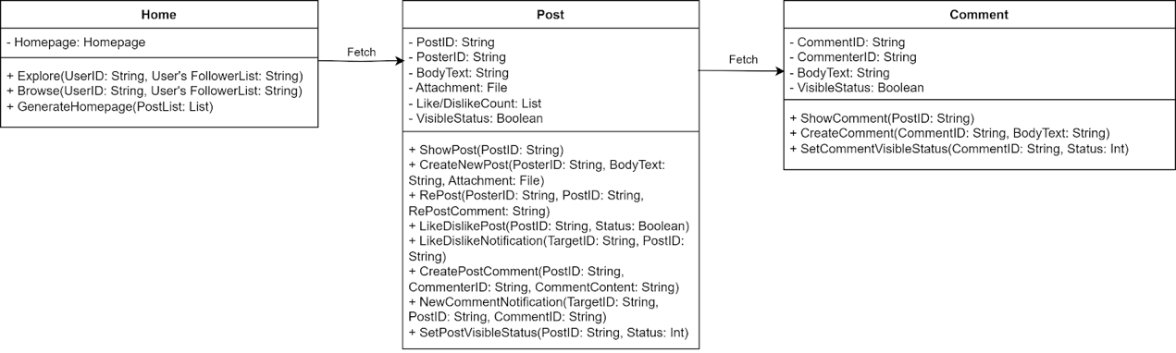

1.2.1.4 Sequence Diagram

1.2.2 Functionality

This component is related to the post and comment part of the blog software. In the homepage, post will be displayed to all users. The post class consists of PostID, PosterID, BodyText, Attachment, Like/DislikeCount and VisibleStatus as its attributes. It would provide actions for users to create his or her own post and for general users to interact with others’ posts. It would also support the admin to delete the post. Comment class consists of CommentID, CommenterID, BodyText and its VisibleStatus as its attributes. This class is related to the comment to a certain post.

1.2.3 Procedures and Functions

Home Class

|  |  |
| --- | --- |
| **Function** | **Description** |
| Explore | The users can explore some posts, according to their like/dislike history with the posts. The poster-selector will find the recommended posts. Then fetch the post and its comment from the database. Finally, Display the posts to the users. |
| Browse | The users can browse the posts from the people the user is following based on the posting time. The poster-selector will find the posts from the post database. Then, display the posts to the users. |

Post Components

|  |  |
| --- | --- |
| **Function** | **Description** |
| ShowPost | Posts can be shown to the author and other users according to their visible status. |
| CreateNewPost | The users can enter their own content such as text, images and videos to create the post. And the post can be further reposted, liked/disliked and commented by other users according to its visible status. |
| RePost | The users can react to a particular post by reposting the post with some of his or her own comments. It would provide interface to conduct comment-related actions for general users and admin. |
| LikeDisplayPost | The users can express their feelings toward the tweet by ticking Like or Dislike which would update the Like/Dislike Count associated with the post. |
| LikeDislikeNotification | The author of the post will receive a notification if his or her post is liked or disliked by other users. |
| NewCommentNotification | The author of the post will receive a notification if his or her post received a new comment by other users. |
| CreatePostComment | The logged-in users can express their ideas or opinions of the post by creating comments. This function is associated with the CreateComment function in the comment class. |
| SetPostVisibleStatus | The user can set the visible status of his or her own post, which is -1, 0, 1. If the status is set to -1, then the post will be deleted by the user or admin. If the status is set to 0, then the post will be private and only be visible to the user. If the status is set to 1, then the post will be public and visible to all other users. |

Comment Components

| **Function** | **Description** |
| --- | --- |
| ShowComment | The comments can be shown to the author and other users according to their visible status. |
| CreateComment | The logged-in users can express their ideas or opinions of the post by creating comments to the post. |
| SetCommentStatus | The users can set the visible status of his or her own comment, which is -1, 0, 1. If the status is set to -1, then the comment will be deleted by the user or the admin. If the status is set to 0, then the comment will be private and only be visible to the user. If the status is set to 1, then the comment will be public and visible to all other users. |

2. UI DESIGN

2.1 User Interface – Authentication

2.1.1 Default Page

When a user first opens our CU Chat website, the default page is displayed. On the default page, there are two buttons: “Log in” and “Sign up”. If users click “Log in”, the login page will prompt. Similarly, if users click “Sign up”, the sign-up page will prompt.

Besides, when users log out from our website, the website will redirect to this default page.

2.1.2 Log-in Page

When the user go to the log-in page, he needs to enter his username and password correctly to log in CUChat before clicking “Login”. Successful log-in will redirect the normal user to normal user’s homepage or redirect the admin to admin’s homepage. Unsuccessful log-in will keep the user remain in log-in page. The user can click “Sign up” to redirect to sign-up page, or click “x” to redirect to default page.

2.1.3 Sign-up Page

New users can provide a valid username and a valid password and click “Next” to sign up for a new account. Upon successful registration, the user will be redirected to the default page. Otherwise, a warning message will be displayed.

2.2 User Interface - Admin Homepage

2.2.1 Admin Homepage

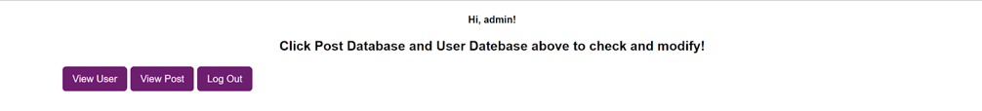

At the admin homepage, the admin can click “View User” to go to user management page, click “View Post” to go to post management page, or click “Log out” to log out the system.

2.2.2 User Management Page

At the user management page, the admin can click “Create New User” to enter data for creating a new user or click the “Update” or “Delete” button displayed below each user to modify or delete that specific user. Each user will be displayed by his user ID, username, and password.

2.2.3 Post Management Page

图形用户界面, 应用程序, Teams

At the post management page, the admin can click “Create New Post” to enter data for creating a new post or click the “Update” or “Delete” button displayed below each post to modify or delete that specific post. Each post will be displayed by it post ID, post title, content, author ID, and availability.

2.3 User Interface - User Homepage

2.3.1 Home Page

When you sign in to CUChat, you'll see a simple menu bar on the left, you can use the buttons on the bar to achieve the pages or functions accordingly. Your username and personal picture are at the bottom left. The explore function will refresh the homepage and show posts that CUChat thinks you'll be interested in based on your likes and activity. If you click on the browser, it updates the homepage with the latest posts from the people you follow. You can get updates from likes or comments in Notifications page. Chat with friends in Messages page and check your bookmarked posts in Favourites page. The Profile page will show your personal profile.You can also find a search bar on the top right of the page. When you use the search function, the home page will display posts related to your search.

2.3.2 Explore/Browse Page

社交网络的手机截图上有男人的照片上写着字

The “Explore” page of the CUChat will display some posts with the most similar tags and the post time. The “Browser” page of the CUChat will display some posts randomly.  The page will bring up more posts when you browse down.

2.3.3 Notification Page

The "Notifications" page of the CUChat will display alerts for new interactions such as likes or dislikes on user posts, new followers, and new comments. You can also use the buttons on the left bar to go to other pages or functions.

2.3.4 Chat Page

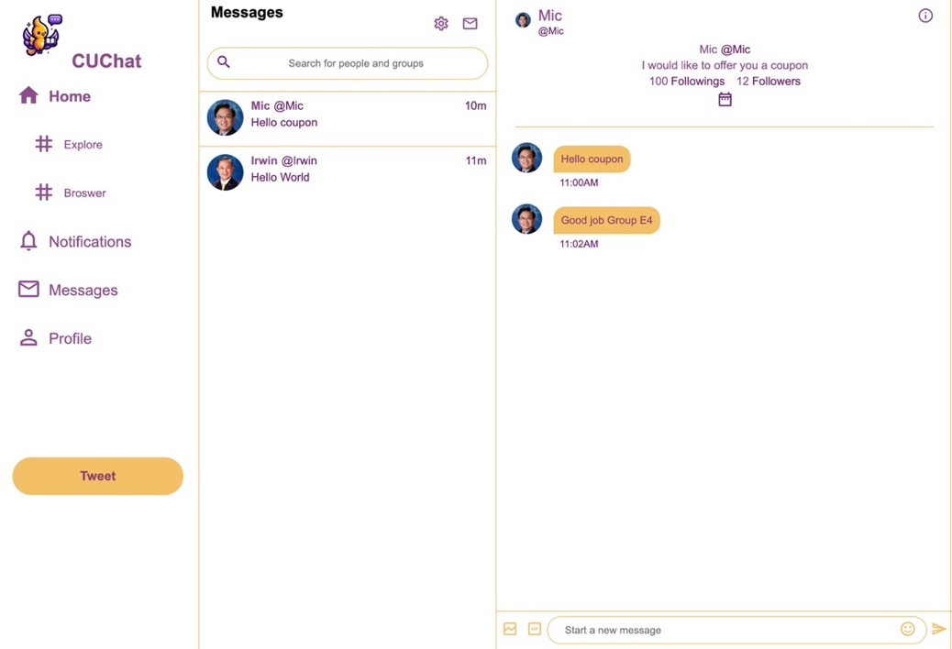

On the chat page, the user can see his conversation sessions with other users listed under the “Messages” panel. There is a search bar that allows users to enter keywords for filtering conversations by username. The selected session will be displayed in the rightmost panel. The opponent user’s profile information will be displayed on the top, and below there will be messages between the user and the opponent user. At the bottom, there is a textarea for entering message content, and an icon for sending the content.

2.3.5 Profile Page

Users can visit the profile page by clicking the “Profile” button in the menu on the homepage. In the top half of the profile page, the profile displays the username, the number of posts made by the user, user background information, user profile photo, and signature. On the right-hand side, there is an 'Edit Profile' button, where users can edit their personal information (username, signature, background, and profile photo) on the edit profile page. Below it, there is a 'Follow/Unfollow' button, allowing users to choose to follow or unfollow other users. In the bottom half of the profile page, the profile displays the user's visible posts, as well as likes and favorites.

2.3.6 Followers/Following Page

By clicking the button “Following” or “Followers” in the profile page, the follow list page would be displayed. If “Following” is clicked, the website will show the following list.  If “Following” is clicked, the website will show the followers list. After clicking a follower or following user, the page would be redirected to the chat page.

2.3.7 Post Details Page

In the post details page, the users can see the details of a certain post, including the number of retweets, likes and dislikes. Moreover, the users can interact with the post such as making comments, like or dislike by kicking the like or dislike button and retweeting the post.

1. Image Reference

<https://www.cse.cuhk.edu.hk/lyu/_detail/wiki/lyu1.jpg?id=home&cache=cache>

<https://scholars.croucher.org.hk/scholars/michael-lyu-rung-tsong>

<https://www.cse.cuhk.edu.hk/irwin.king/_detail/0008-170x250.png?id=home>

<https://www.iso.cuhk.edu.hk/english/publications/CUHKUPDates/article.aspx?articleid=4060>